CHUNG’S TAE KWON DO &
HAP KI DO ACADEMY
Master Sang Chel Chung
6719 N. Northwest highway
Chicago, Illinois 60631
www.chungstkd.com
CALL! 773-631-8989
Welcome! All Chung’s TKD Students and Siblings Drop off starts at 7:30 am age 5 and up! Pick up 5:00pm
 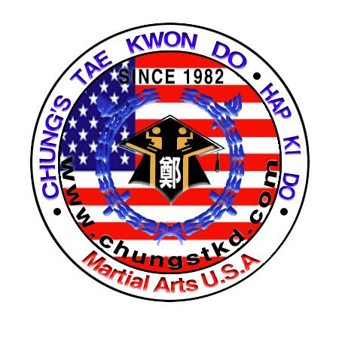  SUMMER CAMP!!!!!!!!!!!!

1, June 19 - 23 Sign up Now, LIMITED SPACE

2, June 26 - 30 Beginning June 19 through September 1, 2017

3, July 03 –07 MON-FRI: Ages 5-13

4, July 10 - 14 Sign up for 1 week to 11 weeks

5, July 17- 21 More that TKD, HKD, Self Defense, Weapons Training

6, July 24 - 28 Outdoor Activities, Games, Movies, and More!

7, July 31 –August 04 Beginners & Advance
8, August 07 - 11 The Best Summer Fun Starts Now!
9, August 14- 18
10. August 21 - 25
11. August 28- Sept 01

Registration Form: Name_______________ Address______________ Birthday________ Phone____________ Email_________
Guardian Name______________________ Signature________________________

Half day 9 - 1pm ( $119.00 ), Full Day 9am - 5pm / week ( $159.00 ). 4 Week+ Special ( $149.00 ).
Pay in advance for 8 weeks or more and get a free uniform and T-Shirt (valued at $80.00 )

